PHYSICS FORM 4
PAPER II
MARKING KEY
(40 MARKS)
NB: ANSWERS FROM THE MARKING KEY ARE NOT ABSOLUTE

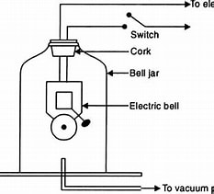
Correct diagram (2 marks)
Any two correct labeling (1 mark)

- Suspend an electric bell inside a bell jar^{.1}
- Connect a vacuum pump to the bell jar as shown in the diagram ¹
- Close the switch before starting the vacuum pump while there is some air inside the bell jar ¹
- Start the vacuum pump to take out he air from the bell jar ¹ and listen to the change in intensity of sound ¹
- Return the air into the jar by opening the stopper slightly ¹ and listen to the change in sound ¹

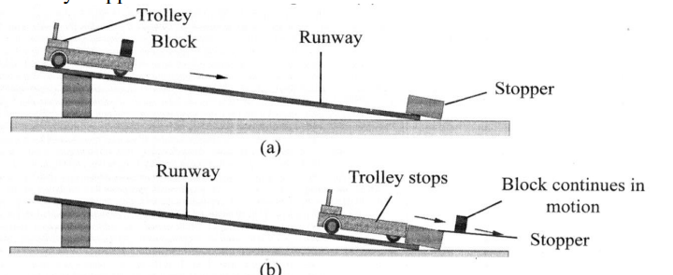

Correct diagram (1 mark)
Any 2 correct labeling (2 marks)
- Place a wooden block on a trolley¹
- Place a stopper at the end of the runway ¹
- Allow the trolley to move down a runway¹.
- Observe what happens to the wooden block once the trolley is stopped suddenly ¹.
- If the wooden block slides off the trolley¹ and continues moving in the same direction the trolley was moving¹ then wooden block is reluctant to stop moving¹.
- Therefore, according to the newton’s first law of motion, a body continues in its state of rest or uniform motion in a straight line unless compelled by some external force to act otherwise¹.

Mass (g) | Time for 10 complete vibrations (s) | Frequency (Hz)
50 | 2 | 5
100 | 3 | 3.3
150 | 4 | 2.5
200 | 5 | 2

A graph of frequency against mass
Frequency (Hz)
Mass (g)
- 1 mark for any 2 correct values for time and 1 mark for any 2 correct values for frequency
- 1 mark for correct scale and labelling (y-axis) and 1 mark for correct scale and labelling (x-axis)
- 1mark for any 2 correct points
- 1mark for correct straight-line graph (line of best fit)
- Mass of a body attached to a spring is inversely proportion to frequency of an oscillating system.

- 1 mark for any 3 correct values
Number of cells | Ammeter reading, I (A) | Voltmeter reading (V) | Resistance  V/I (Ω)
1 | 0.4 | 1.4 | 3.5
2 | 0.8 | 2.6 | 3.25
3 | 1 | 4.2 | 4.2
4 | 1.3 | 5.6 | 4.3

A graph of voltage against current
Voltage(V)

Current (A)
  - 1 mark for correct scale and labelling (y-axis) and 1 mark for correct scale and labelling (x-axis)
  - mark for any 2 correct points
  - 1mark for correct straight-line graph (line of best fit)

h. As voltage increases, current also increases (direct relationship) (1 mark)
OR current is directly related to voltage

Note : Subject Teacher should carry out experiments for question 3 and 4 to verify the answers

